

**Qualcomm Car-to-Cloud Platform**

**LMS 1.3 Backend Setup Document**

**Version No.1.0**

|  |  |  |  |
| --- | --- | --- | --- |
|  | **Prepared By / Last Updated By** | **Reviewed By** | **Approved By** |
| **Name** | Christo Jose |  |  |
| **Role** | Sr.Associate |  |  |
| **Signature** |  |  |  |
| **Date** |  |  |  |

**Table of Contents**

1 Document Overview 3

2 Local Setup 3

3 AWS Fargate Setup 5

# Document Overview

Goal of this document is to provide the Setup details for LMS 1.3 Backend.

# Local Setup

1. Python Installation

Install python version **3.8** from OneIT in your system. Follow the below documentation.

https://docs.python.org/3.8/using/windows.html

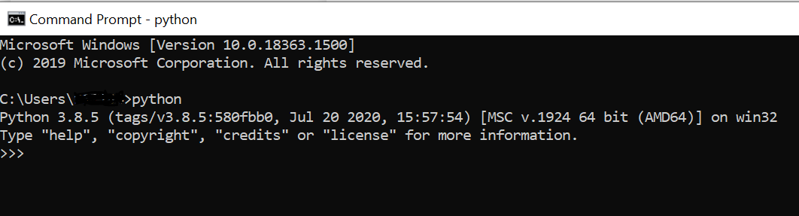

Upon successful installation you must be able to access python from the command prompt as shown in the above picture.

1. Pip and Virtualenv Installation

Setting up pip and virtual environment. Follow the below documentation.

https://packaging.python.org/guides/installing-using-pip-and-virtual-environments/

**Creating a virtual environment**

1. Open command prompt and navigate to the location where virtual environment needs to be installed.
2. Enter following command to the terminal **python3 -m venv <virtual_environment_name>**

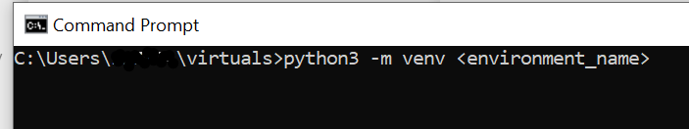

1. After the creation of the env before you can start installing or using packages in your virtual environment, you will need to activate it.
2. Use this command to activate: **source env/bin/activate**
3. Run the application using PyCharm
4. From the main menu, choose File | New Project

In the dialog that opens, select the directory that contains the project code.

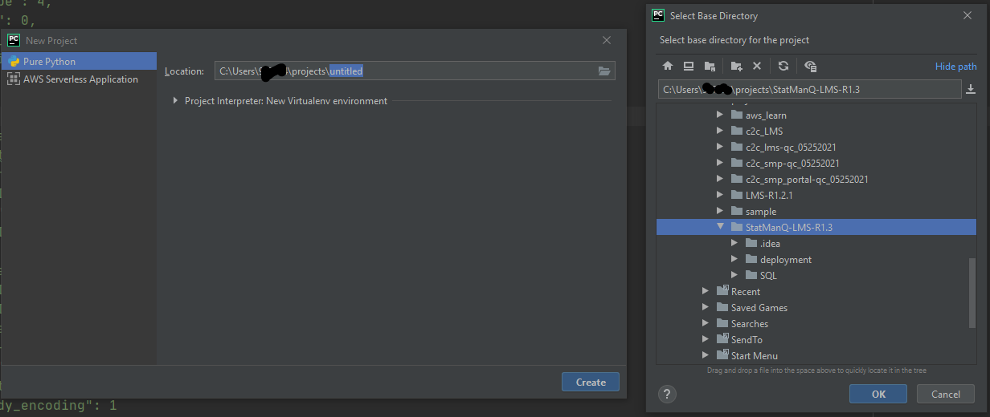

1. Click OK.
2. Configure a Python interpreter, choose File | Settings | Project | Python Interpreter.
3. Click the Python Interpreter selector and choose Add Interpreter.
4. Select Add. In the left-hand pane of the Add Python Interpreter dialog,
5. Select Virtualenv Environment.

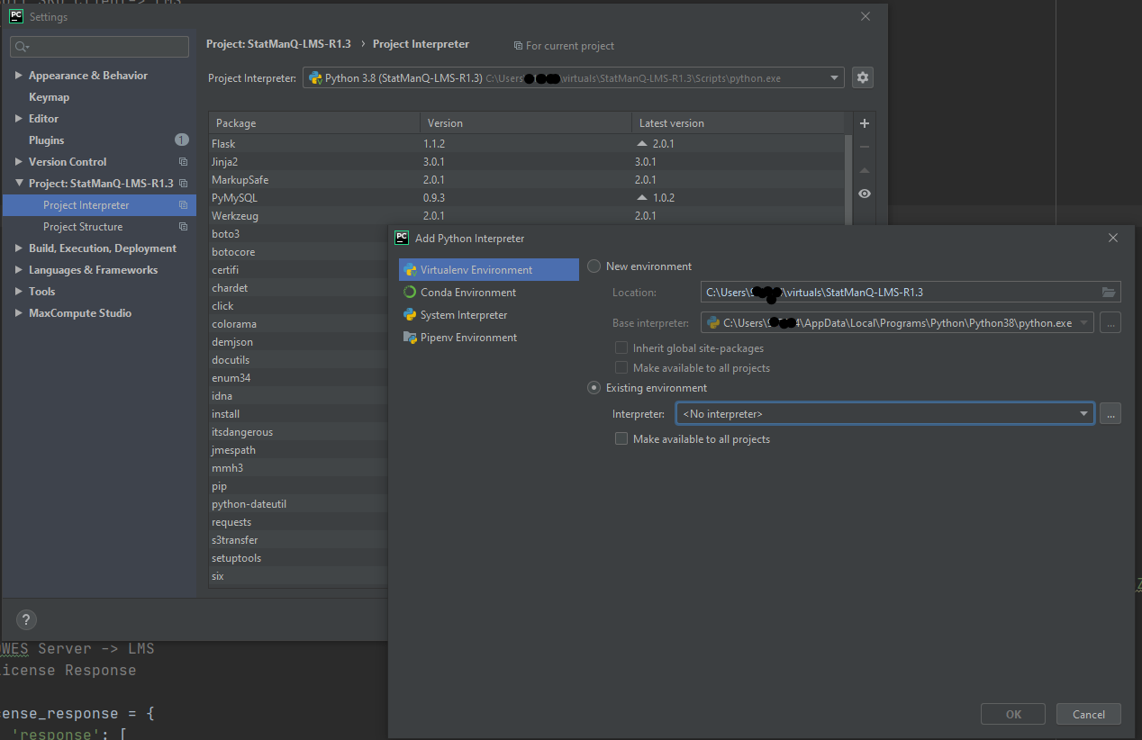

1. Select “Existing environment” Expand the Interpreter list and select any of the existing interpreters. Alternatively, click Select an interpreterand specify a path to the Python executable in your file system,
2. Click OK to complete the task.

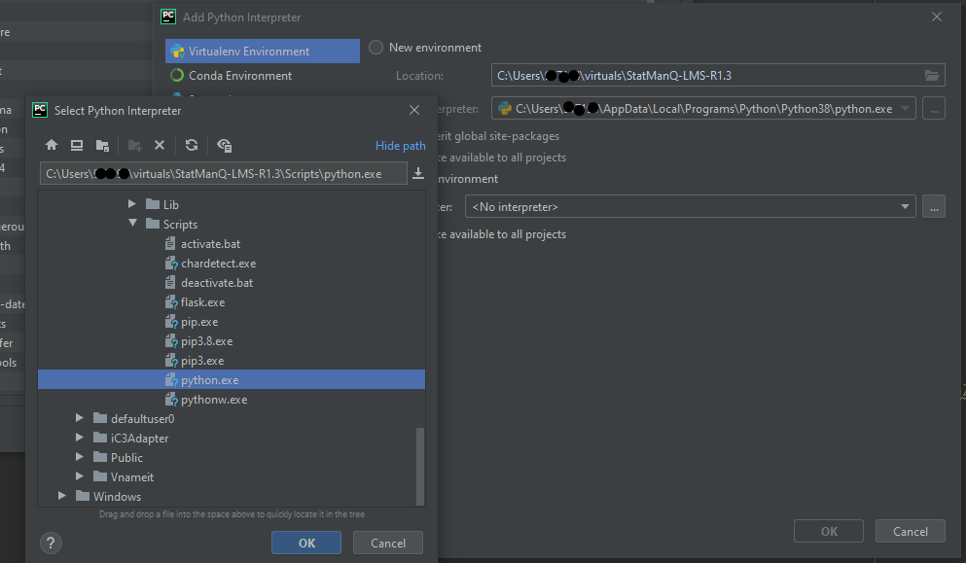

1. Add Run Configuration PyCharm
2. Click on “Add configuration” from the toolbar and click the ‘+’ button to add a Python configuration.
3. Enter a name for the configuration.
4. Choose the **app.py** for the script path.
5. Click OK

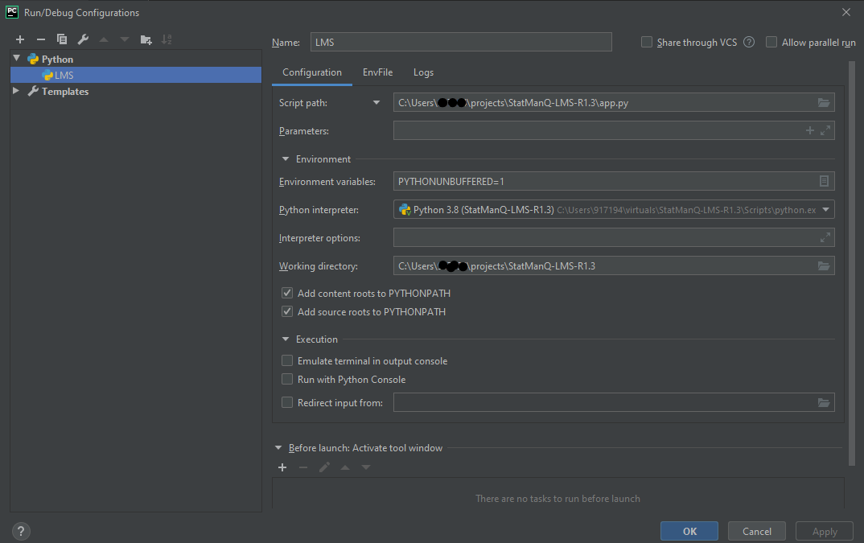

1. Run the code using PyCharm
2. From the toolbar click on the Run button to start the application.

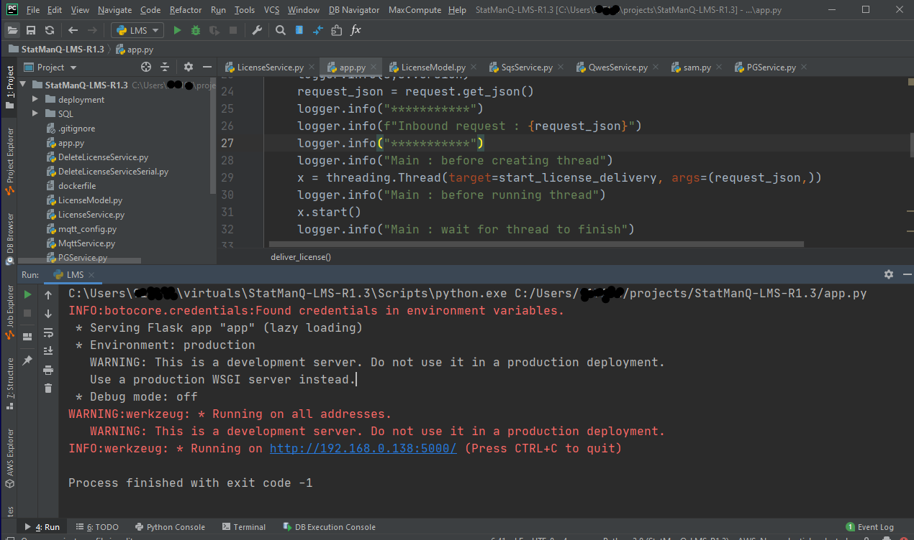

# AWS Fargate Setup

1. Update AWS account specific details

Update the received ECS Fargate Cloudformation script from path “/deployment/ LMS-ECSv1.3.yml” with the AWS account specific details for

1. VPC
2. subnet
3. ELBSubnets
4. DBHost
5. DBUser
6. QWESClientID
7. QWESUserName

Note : Commented out the reference and declaration of “LoadBalancerHTTPSListener” as certificate was not available, this will beaded back once the ssl certificate is available

1. Created a Jenkins job perform the below steps
2. Build the project
3. Create a docker image
4. Upload the docker image to ECR

Container image will be available in the AWS console ECR screen

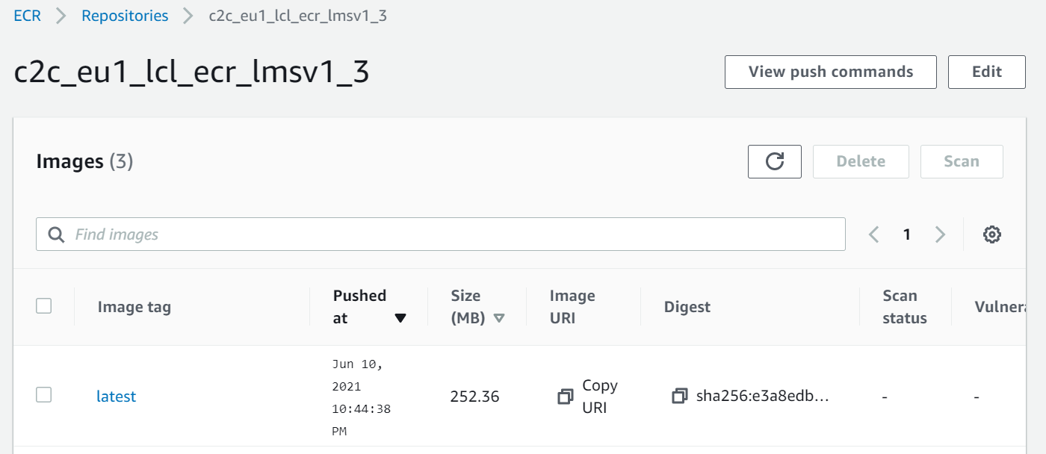

1. Update ECS fargate to use the new ECR image

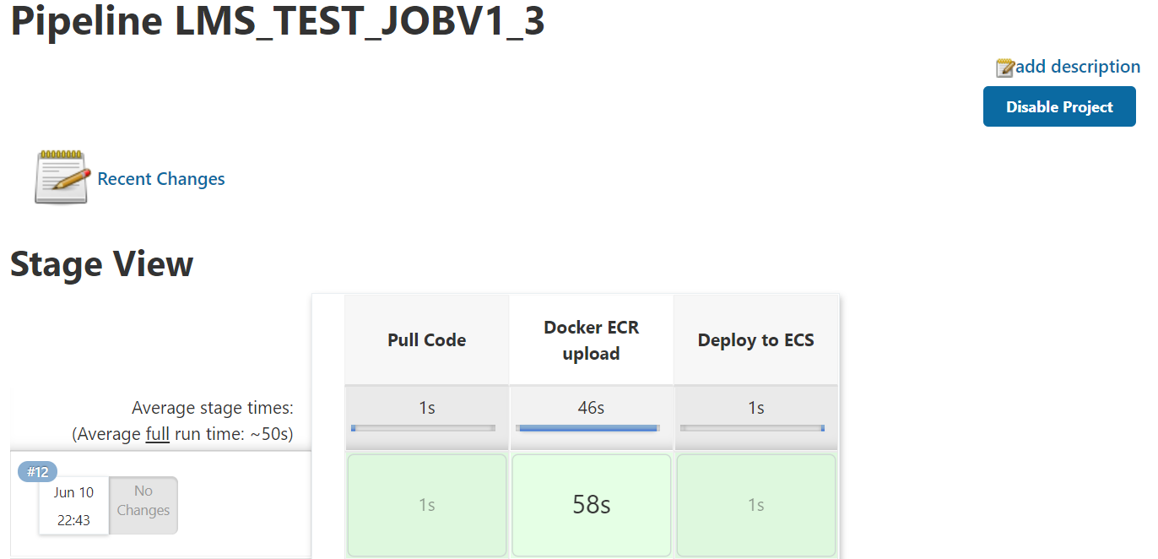

1. Create ECS Fargate using Cloudformation script
2. Navigate to AWS console Cloudformation screen

[https://console.aws.amazon.com/cloudformation/home?region=us-east-1#](https://console.aws.amazon.com/cloudformation/home?region=us-east-1)

1. Create a new Stack

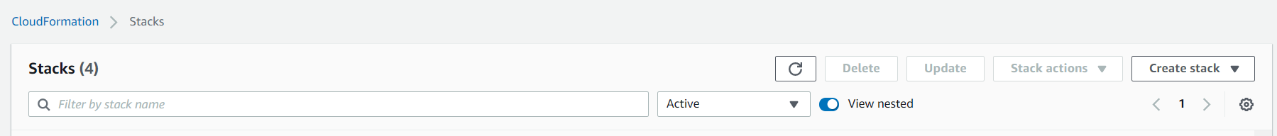

1. Upload the Updated cloud formation script received - LMS-ECSv1.3.yml

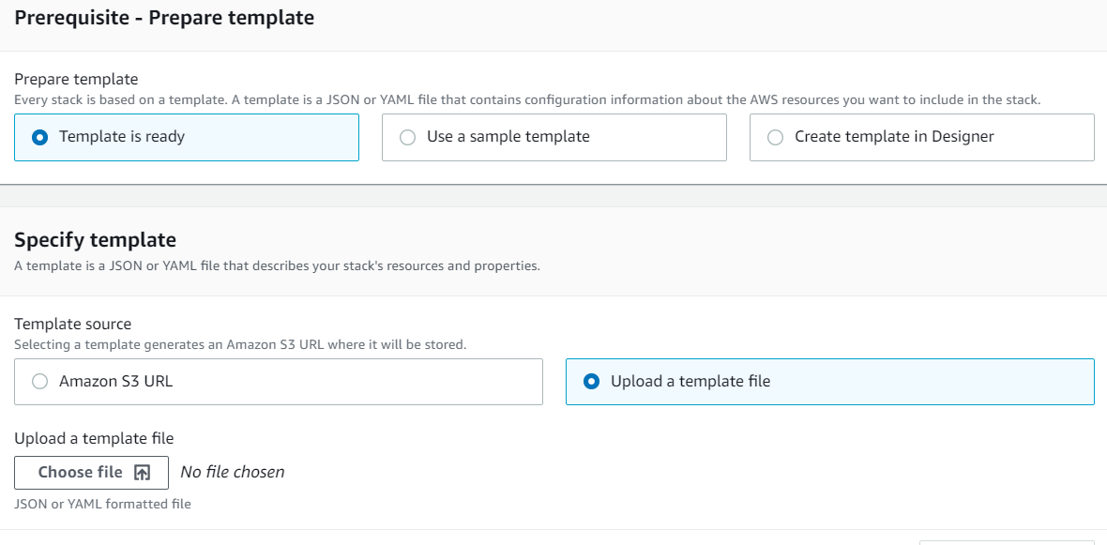

1. Click Next to Enter the below parameter values
2. Stack Name
3. ContainerImage
4. DBPassword
5. QWESPassword

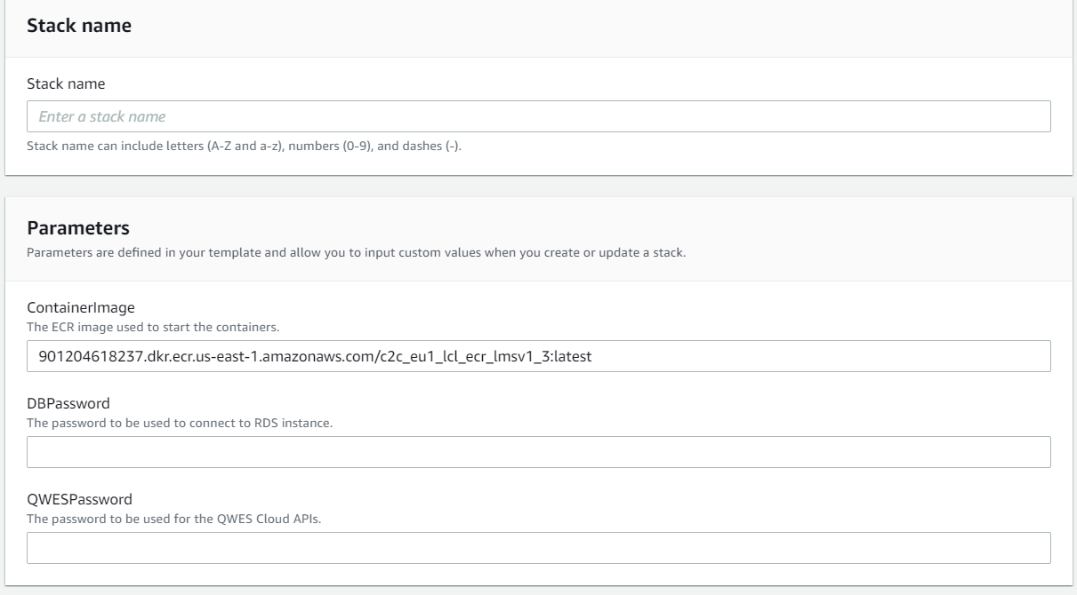

1. Click to proceed with the Stack creation
2. Once the Process is complete , Stack status would be “CREATE COMPLETE

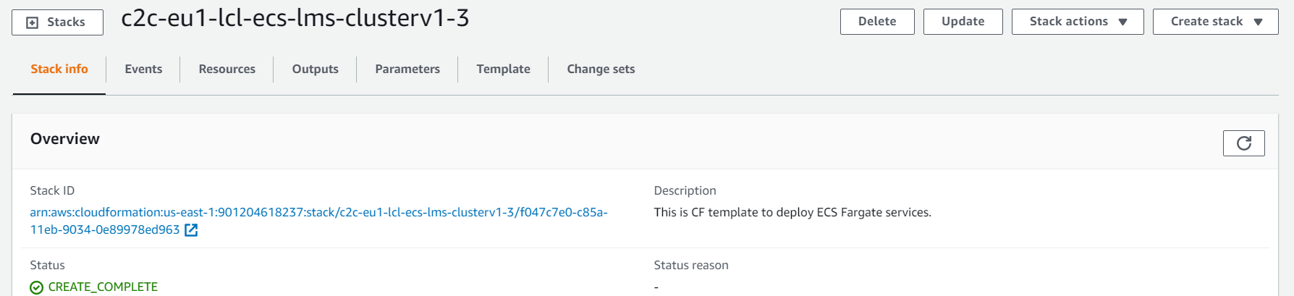

1. View the resources created as part of the cloud formation script by clicking on the Resource tab

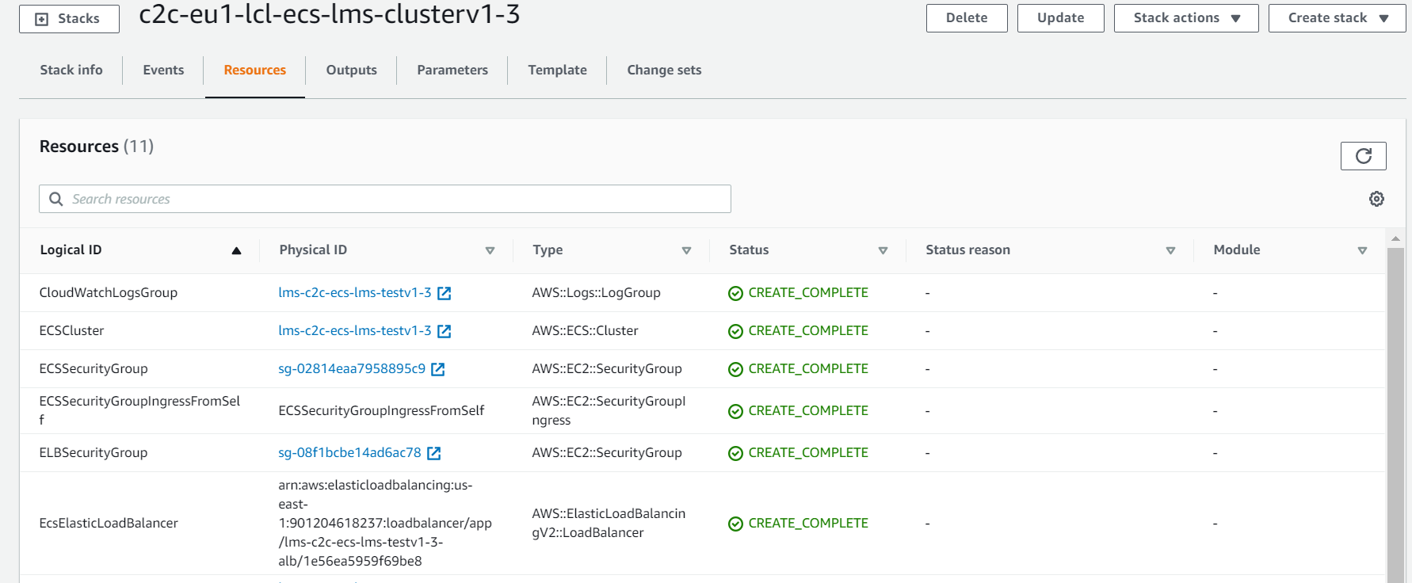

1. Confirm ECS Fargate is running from the AWS Console – ECS screen

